**Experiment No.: 1 Date:28/10/2022**

**Aim:**

Model a simple HTML file to demonstrate the use of different tags.

**CO1:**

Explore markup languages features and create interactive web pages using them.

**Procedure:**

<html>

<head>

<title>

WELCOME

</title>

</head> <body <font color="black" bgcolor="lime">

<fieldset>

<center>

<font color="blue"><h1><marquee>WELCOME</marquee></h1>

<h2>

<b><font color="black">My Website</font></b>

</h2>

<h2>

<a href="cars.html"><br>helloo!!</a>

<br><br>

<br><br></center>

</h2><h2

<ul TYPE="square">

<li>hai</li>

<li>hello</li>

<li>how are you</li>

<li>are you ok </li>

</ul>

</h2>

<h2>

Question Words

<ol>

<li>who are you</li>

<li>how are you </li>

<li>where are you from</li>

<li>how did you</li>

</ol>

</font></h2>

</fieldset>

</body>

</html>

**Output Screenshot:**

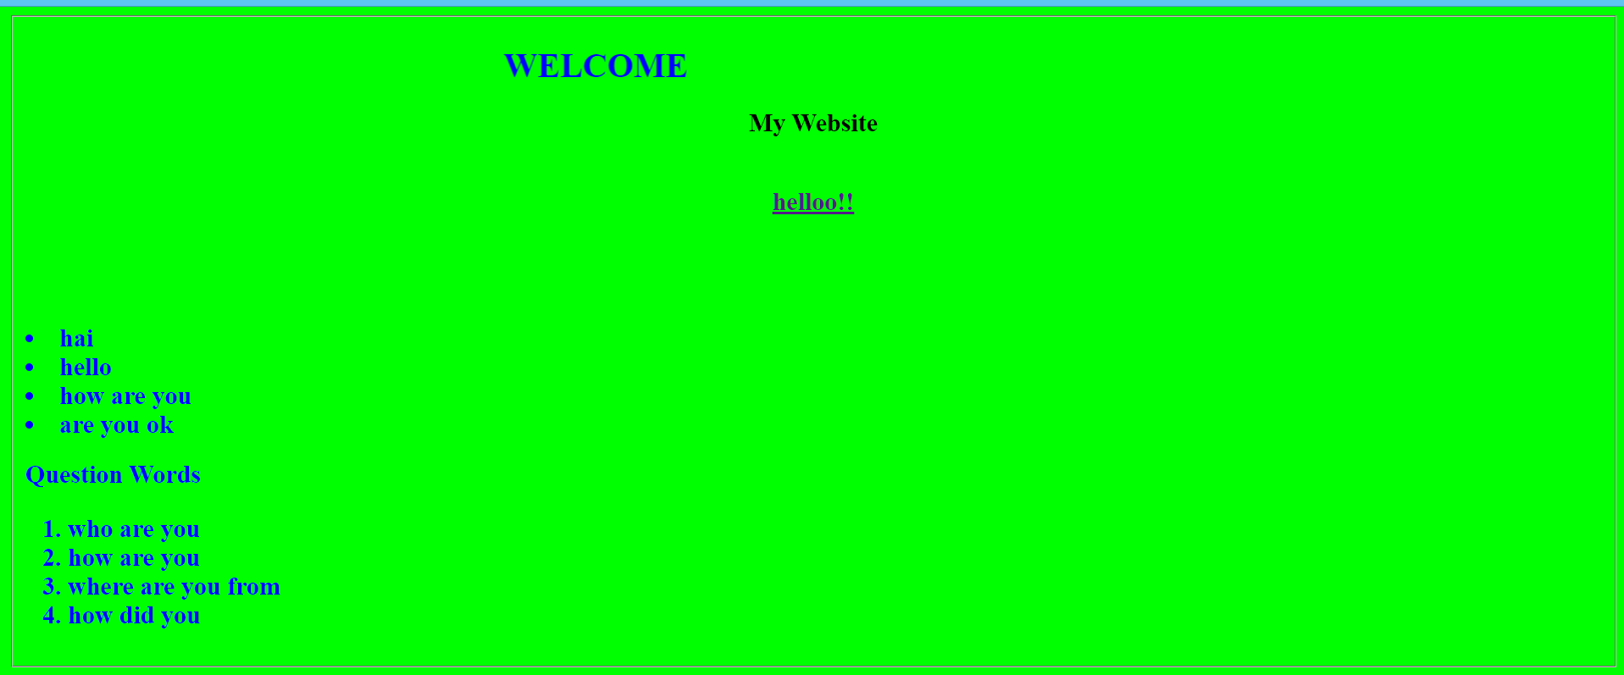

**Result**

The program was executed and the result was successfully obtained. Thus CO1 was obtained.

**Experiment No.: 2 Date:28/10/2022**

**Aim:**

Create a HTML file to link to different HTML page which contains images, tables, and also link within a page.

**CO1:**

Explore markup languages features and create interactive web pages using them.

**Procedure:**

***(Main page):***

<html>

<head>

<title>WELCOME</title>

</head> <body <font color="lime" background="https://c4.wallpaperflare.com/wallpaper/819/896/34/car-honda-nsx-nissan-gtr-r34-wallpaper-preview.jpg">

<center>

<font color="lime"><h1>WELCOME TO THE WORLD OF CARS</h1>

<h2>

<b><font color="yellow">HYRUZ GROUP Website</font></b>

</h2>

</center>

<h2>

NISSAN GTR R-34<a href="cars.html"><br>ABOUT GTR</a>

<br><br>

<br><br>

</h2><h2>

GALLERY <a href="GALLERY.html"> <br>CAR GALLERY</a><br><br>

CAR MODELS <a href="tables.html"> <br>INDIAN CAR COMPANIES</a><BR><BR>

JDM COMPANY

<ul TYPE="square">

<li>nissan</li>

<li>toyota</li>

<li>honda</li>

<li>mistibushi</li>

</ul>

</h2>

<h2>

JDM MODELS

<ul>

<li>supra mkv4</li>

<li>gtr r 34</li>

<li> honda civic</li>

<li>mazda rx7</li>

</Ul>

</font></h2>

</body>

</html>

***(Link pages):***

html>

<head>

<title>

automobiles

</title>

</head>

<body background="https://c4.wallpaperflare.com/wallpaper/985/116/48/forza-horizon-3-car-2k-nissan-skyline-gt-r-r34-wallpaper-preview.jpg" width="1000" height="600">

<font color="white"><h1>NISSAN GTR R-34</h1></font>

<font color="white"><p>The Nissan GT-R is a high-performance sports car and grand tourer produced by Nissan, unveiled in 2007.[3][4][5] It is the successor to the Skyline GT-R, a high performance variant of the Nissan Skyline. Although this car was the sixth-generation model to bear the GT-R name, the model is no longer part of the Nissan Skyline model line up since that name is now reserved for Nissan's luxury-sport vehicles. The GT-R is built on the exclusively-developed Nissan PM platform, which is an enhanced evolution of the Nissan FM platform used in the separate Nissan Skyline luxury car and the Nissan Z sports car. The GT-R abbreviation stands for Gran Turismo–Racing, obtained from the Skyline GT-R</p></font>

<img src="https://images.hdqwalls.com/wallpapers/red-nissan-gtr-r34-02.jpg" width="1700" height="800"></img>

</body>

</html>

***(Link pages2):***

<html>

<head>

<title>

</title>

</head>

<body background="https://wallpaperaccess.com/full/11207.jpg">

<h1><center> Hyruz Group Car Garage</center></h1>

<font color="white"> <marquee> <h2>It is a official website of hyruz group.This car are owned by HZ.For paid promotion contact as!!</h2> </marquee></font>

</body>

</html>

***(Link pages3):***

<html>

<head>

<title>tables</title>

</head>

<center><body bgcolor="YELLOW"><h1>CAR BRANDS</h1></center>

<center>

<table border="5" height="600px" width="1300px" bordercolor="black"cellpadding="10"></center>

<tr>

<th>COMPANY NAME </th> <th>MODEL 1</th><th>MODEL 2</th><th>MODEL 3</th><th>MODEL 4</th><th>MODEL 5</th>

</tr>

<tr>

<th> Maruthi</th><td>Alto800</td><td>WagonR</td><td>Swift</td><td>S-Presso</td><td>Grand vitara</td>

</tr>

<tr>

<th>Toyota</th><td>Innova</td><td>Fortuner</td><td>Supra mkv</td><td>Glanza</td><td>Land cruiser</td>

</tr>

<tr>

<th> Honda</th><td>City</td><td>Jazz</td><td>Amaze</td><td>WRV</td><td>BRV</td>

</tr>

<tr>

<th> Tata </th><td>Harrier</td><td>Saffari</td><td>Tiago</td><td>Punch</td><td>Indica</td>

</tr>

</table>

</body>

</html>

**Output Screenshot:**

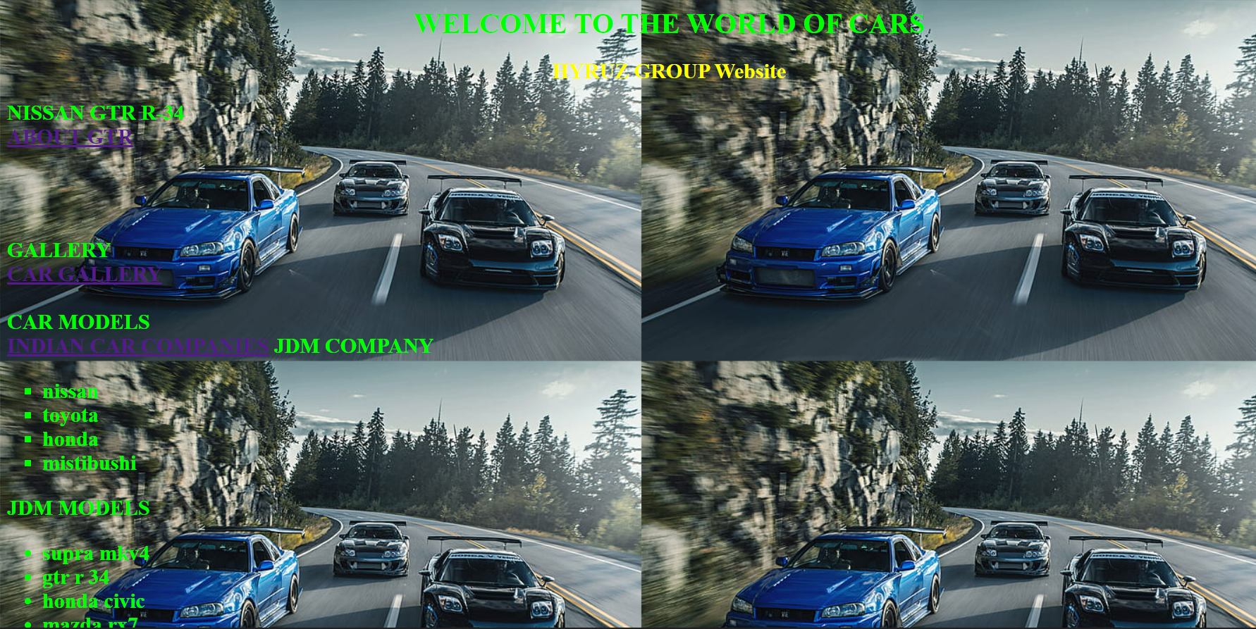

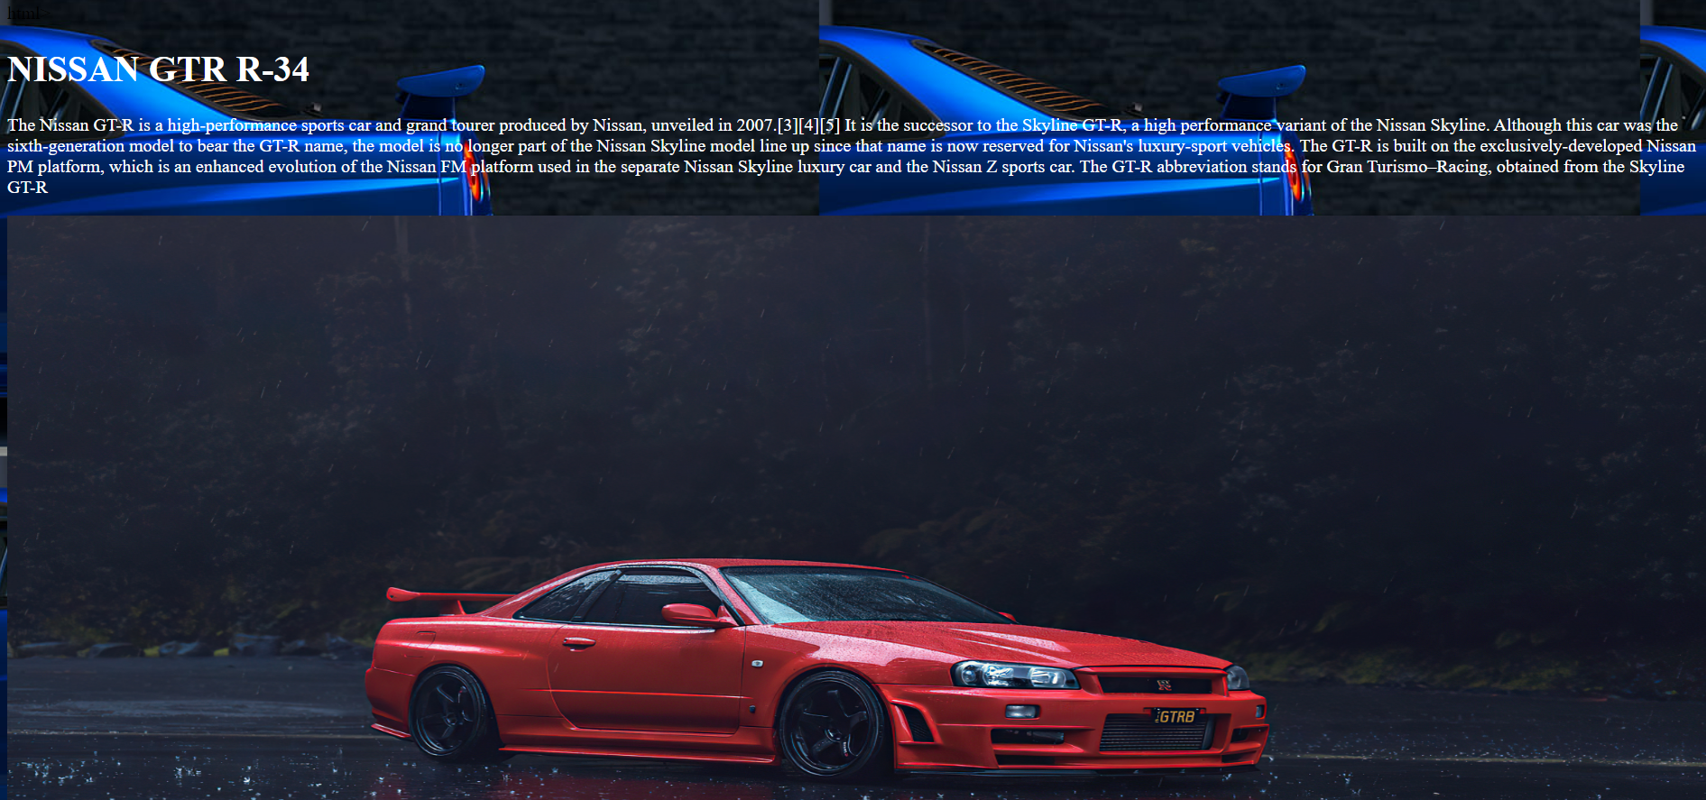



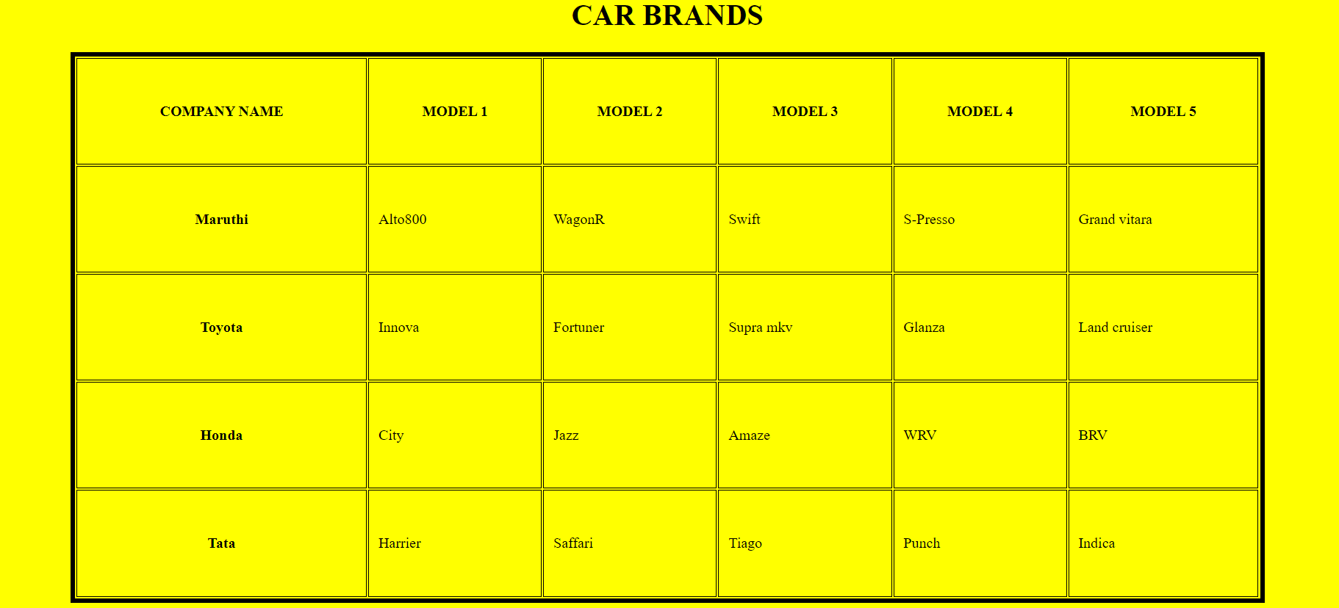

**Result**

The program was executed and the result was successfully obtained. Thus CO1 was obtained.

**Experiment No.: 3 Date:28/10/2022**

**Aim:**

Create a HTML page with different types of frames such as floating frame, navigation frame & mixed frame.

**CO1:**

Explore markup languages features and create interactive web pages using them.

**Procedure:**

***Navigation Frame:***

<html>

<head>

<title>Example of HTML Frames using row attribute</title>

</head>

<frameset cols = "50%, 50%">

<frame name = "top" src = "gallery.html" />

<frame name = "main" src = "cars.html" />

</frameset>

</html>

***Floating Frame:***

<html>

<head>

<title></title>

</head>

<body>

<h1>Floating Frame</h1>

<iframe name='floating_frame' src='difftag.html' width="3000" height="1500">

</iframe>

</body>

</html>

***Mixed Frame:***

<html>

<frameset rows="25%,75%">

<frame src="GALLERY.html" />

<frameset cols="25%,75%">

<frame src="tables.html" />

<frame src="difftag.html">

</frameset>

</frameset>

</html>

**Output Screenshot:**

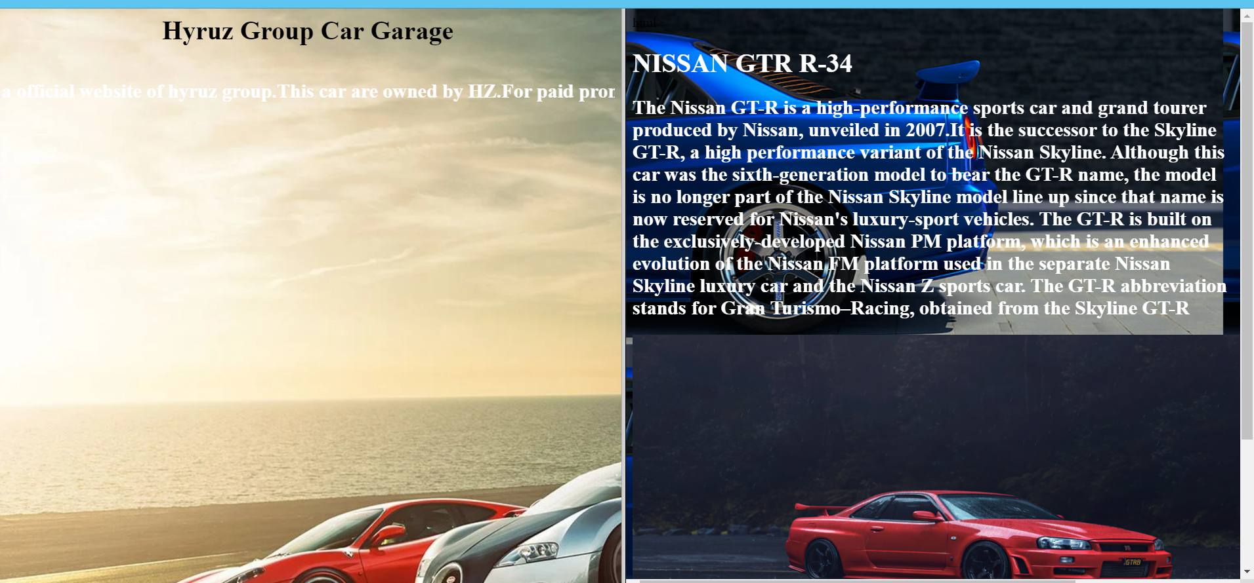

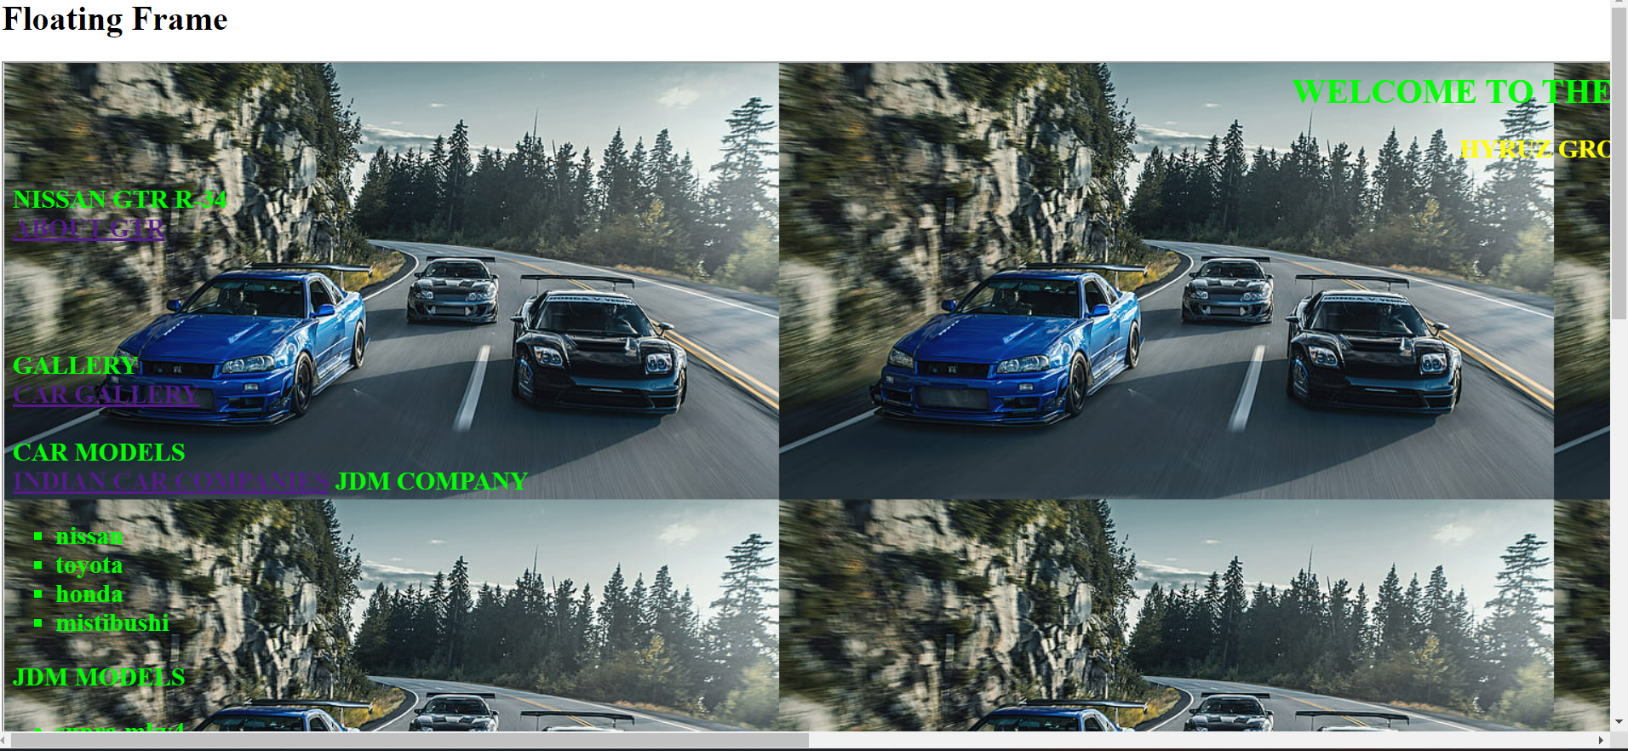

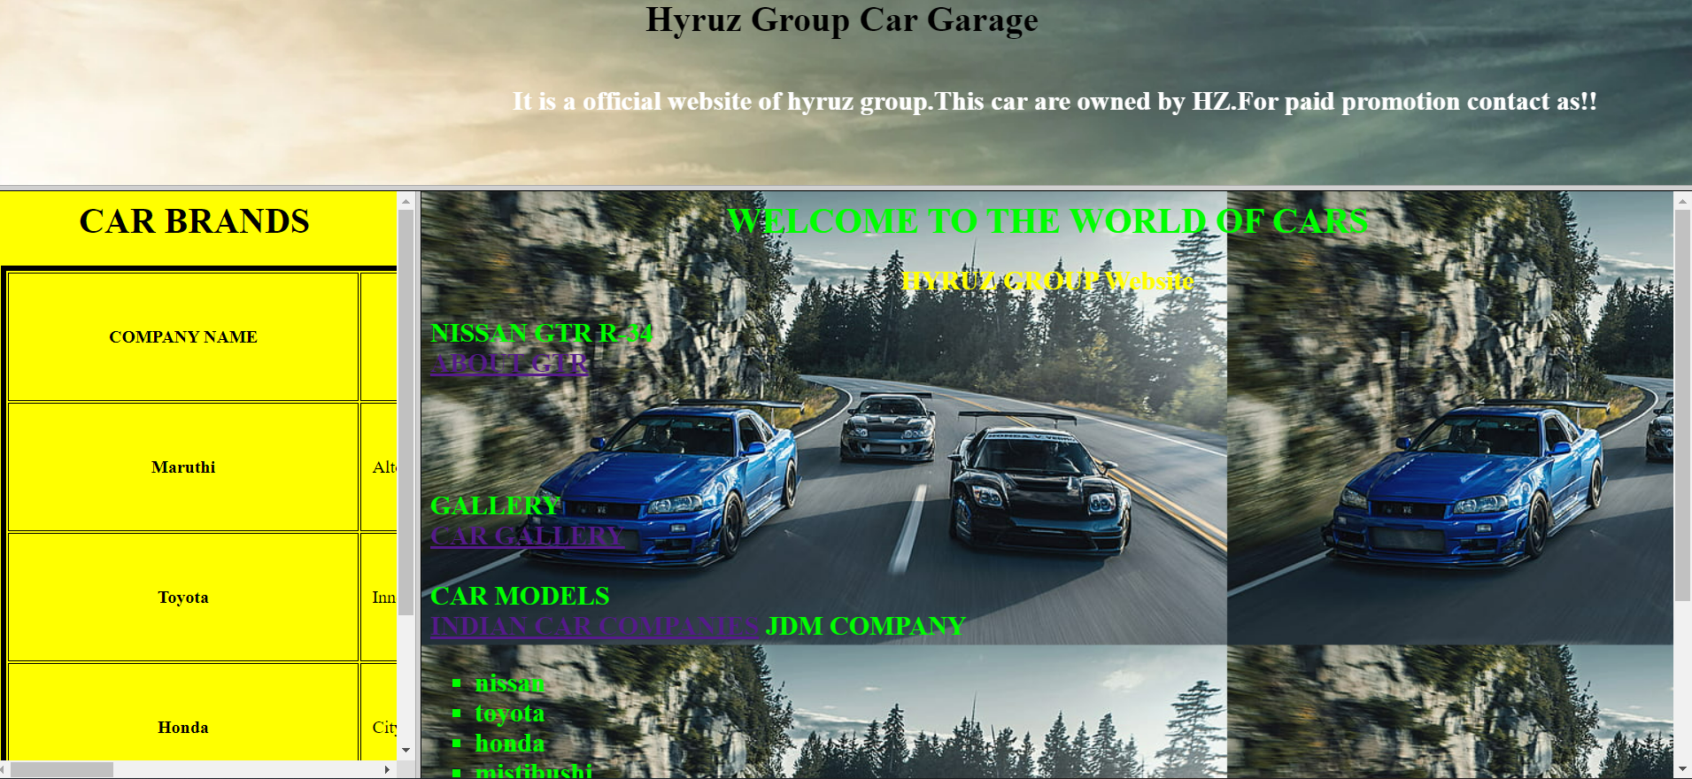

**Result**

The program was executed and the result was successfully obtained. Thus CO1 was obtained.

**Experiment No.: 4 Date:28/10/2022**

**Aim:**

Analyze CSS by applying the different styles using inline, external & internal style sheets in a HTML file.

**CO1:**

Explore markup languages features and create interactive web pages using them.

**Procedure:**

<html>

<head>

<style>

h2{color:white;

}

p{color:black;

}

</style>

<link rel="stylesheet" href="css1.css">

</head>

<body>

<h1 style="color:silver";"font_size:12px";><u><b>Inline,Internal,External CSS</b></u></h1>

<h2><u>Inline CSS:</u></h2> <p>Requires the style attribute placed inside an HTML element.<br></p>

<h2><u>Internal CSS:</u></h2><p> Requires the tag style element placed inside the head section of an HTML file.<br></p>

<h2><u>External CSS:</u></h2> <p>Requires the link element placed inside the head section of an HTML file.</p>

</body>

</html>

***External css:***

body {

background-color:purple;

}

h1{

text-align:center;

font-size:60px;

}

h2{

font-size:40px;

}

p{

font-size:20px;

}

**Output Screenshot:**

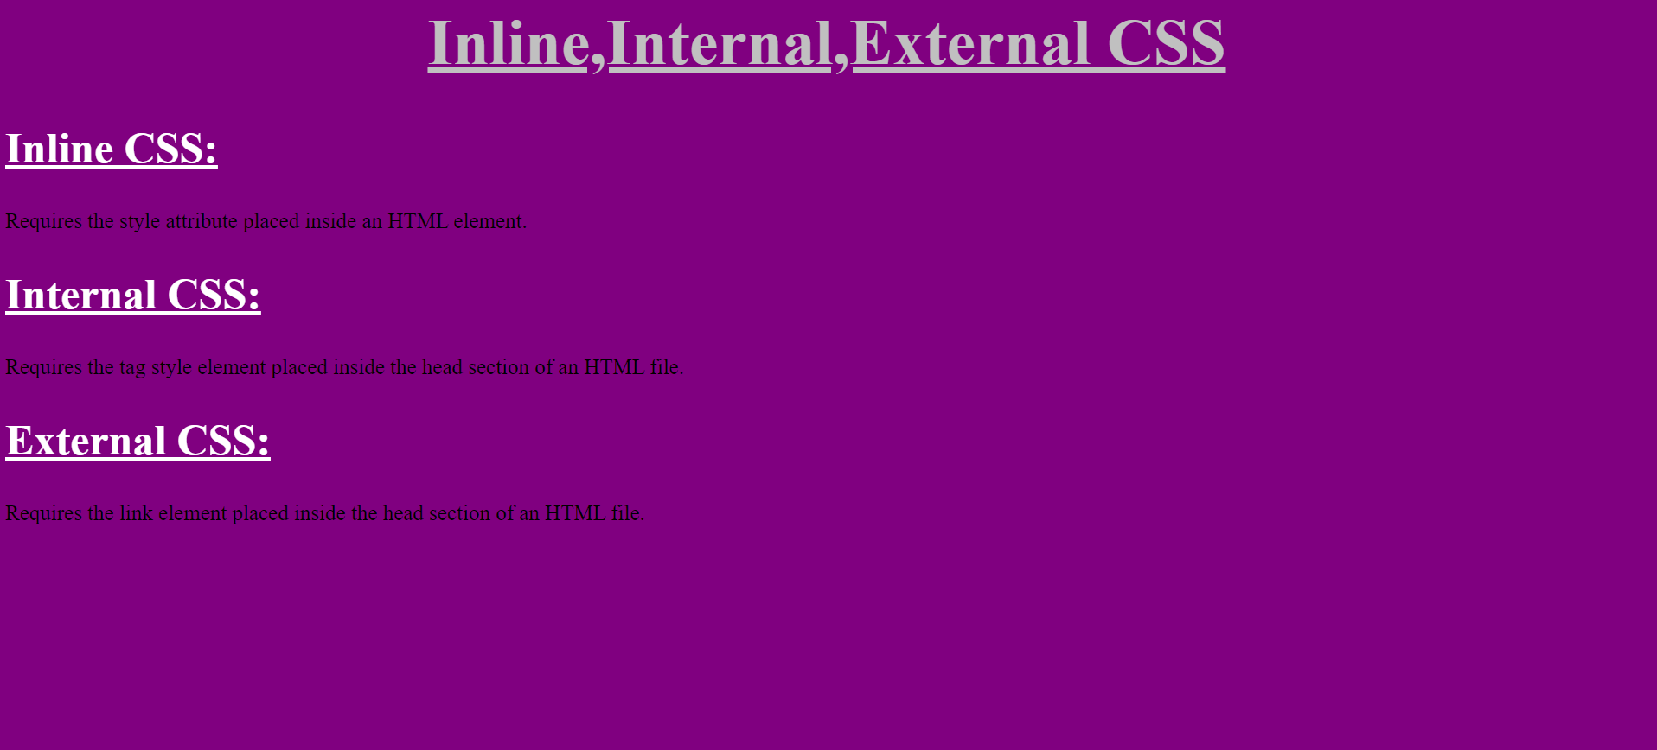

**Result**

The program was executed and the result was successfully obtained. Thus CO1 was obtained.

**Experiment No.: 5 Date:28/10/2022**

**Aim:**

Demonstrate a registration form using HTML.

**CO1:**

Explore markup languages features and create interactive web pages using them.

**Procedure:**

<html>

<head>

<title>

Application Form

</title>

</head>

<body background="https://c0.wallpaperflare.com/preview/391/321/157/botany-dark-green-plants-fern-foliage.jpg">

<form action="/login.php">

<h1> <center><font color="7F7F7F">Student Registration Form </font> </center><h1>

<table style="color:white"width="30%"height="60" align="center" border="7" bordercolor="7F7F7F" cellpadding="10">

<tr>

<th>First name&nbsp; <input type="text" name="text"></th></tr>

<tr><th>Last name&nbsp; <input type="text" name="text"></th></tr>

<tr><th>Address&nbsp;<textarea rows="1" cols="20"></textarea></th></tr>

<tr><th>Previous Institution&nbsp;<input typr="text" name="college"></th></tr>

<tr><th>Gender&nbsp;&nbsp;

<input type="radio" name="gender" value="male"> Male<br>

&nbsp;

&nbsp;

&nbsp;

&nbsp;

&nbsp;

&nbsp;

&nbsp;

&nbsp;

&nbsp;

&nbsp;

<input type="radio" name="gender" value="female"> Female</th></tr>

<tr><th>Date of Birth&nbsp;&nbsp;&nbsp;

<input type="date" name="date"></th></tr>

<tr><th> E-maili&nbsp; &nbsp;&nbsp;<input type="email" name="email"></th></tr>

<tr><th> Mobile number<input type="tel" name="number"></th></tr>

<tr><th>District&nbsp;&nbsp;&nbsp;&nbsp;&nbsp;&nbsp;&nbsp;

<select name="District">

<option selected>Kottayam</option>

<option selected>Idukki</option>

<option selected>Kollam</option>

<option selected>Kannur</option>

<option selected>Thrissur</option>

<option selected>Select district</option>

</th></tr>

<tr><th> <input type="submit" value="SUBMIT">

<input type="reset" value="RESET"></th></tr>

</select>

</table>

</form>

</body>

</html>

**Output Screenshot:**

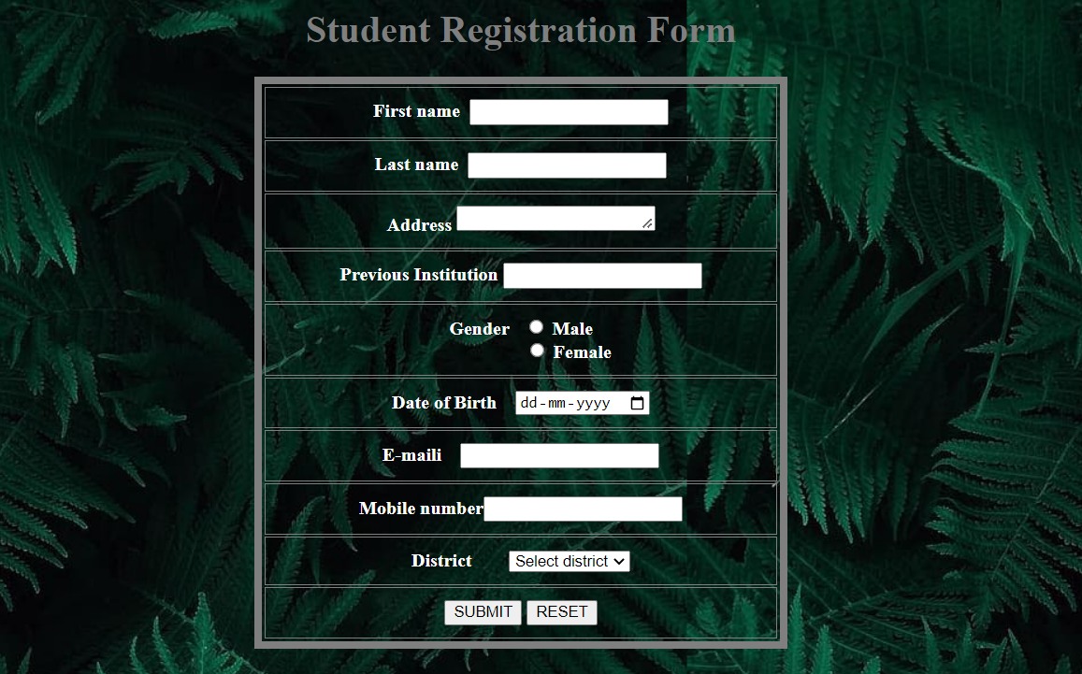

**Result**

The program was executed and the result was successfully obtained. Thus CO1 was obtained.

**Experiment No.: 6 Date:28/10/2022**

**Aim:**

Create a resume.

**CO1:**

Explore markup languages features and create interactive web pages using them.

**Procedure:**

<html>

<head>

<link rel="stylesheet" href="ressume.css">

</head>

<body>

<center><h1>RESUME</h1></center>

<table width="500" height="600"align="center">

<tr>

<th class="head"> <img class="profileimg" src="https://media.istockphoto.com/vectors/man-in-fashion-suit-template-for-web-empty-face-of-business-man-vector-id1226652118?k=20&m=1226652118&s=612x612&w=0&h=3PKIOmE8S71ZOLKpFJKIy__iRDPDhr9TuECndyaF2mQ="></th>

<td class="head2"> <ul><br>

<li>Sahid Siddik</li>

<li>09876543211</li>

<li>Kottayam</li></td></tr>

</ul>

<tr><th class="head">SKILLS</th>

<td class="head2"> <ul><br>

<li>c</li>

<li>Python</li>

<li>Designing</li>

<li>Programming</li>

<li>Computer Science</li>

</ul></td></tr>

<tr><th class="head">INSTITUTIONS</th>

<td class="head2"><ul>

<a href="https://sgcaruvithura.ac.in/">

<li> SGC ARUVITHURA </li><BR>

</a>

<a href="https://www.ajce.in/">

<li>AJCE KANJIRAPPALLY</li>

</a>

</ul></td></tr>

<tr><th class="head">CERTIFICATES</th>

<td class="head2"><ul>

<li>Python</li>

<li>AWS</li>

</ul></td></tr>

<tr><th class="head">ACTIVITIES</th>

<td class="head2"><ul>

<li>Recycling Club</li>

<li>Gardening Club</li>

<li>Book Club</li>

</ul></td></tr>

</table>

</body>

</html>

CSS:

body{

background-image:url('https://images.pexels.com/photos/952670/pexels-photo-952670.jpeg?auto=compress&cs=tinysrgb&w=600');

}

body{

color: white;

margin-center:220px;

}

.profileimg{

max-width: 100px;

height: 100px;

border-radius: 50px;

}

.head

{

font-size:18px;

}

.head

{

background-color:teal;

}

.head

{

color:white;

}

.head2

{

background-color:#FAEBD7;

color:black;

}

**Output Screenshot:**

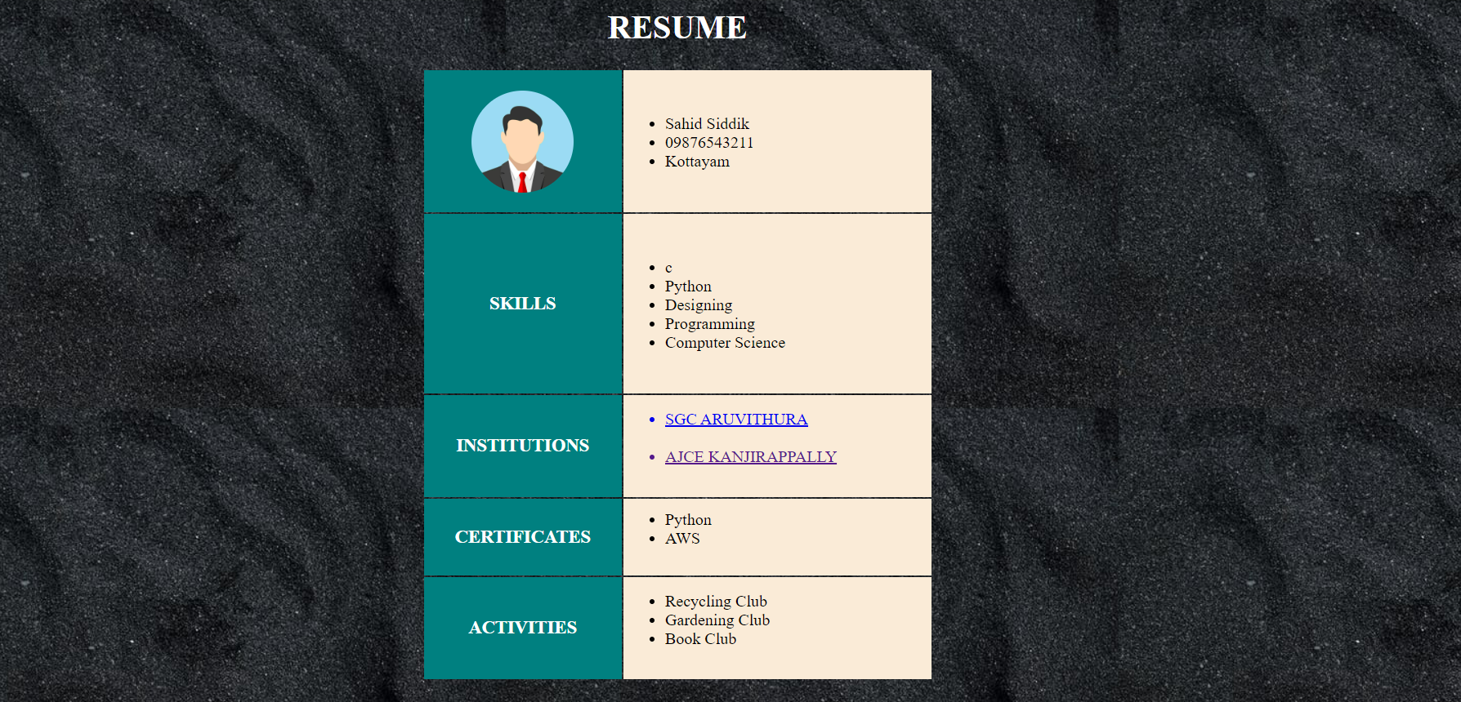

**Result**

The program was executed and the result was successfully obtained. Thus CO1 was obtained

**Experiment No.: 7                                                                         Date:28/10/2022**

**Aim:**

Create a HTML page to explain the use of various predefined function in a string and

math object in javascript.

**CO2:**

Learn and design client-side validation using scripting languages.

**Procedure:**

<html>

<head>

<p id="demo"> </p>

</head>

<body>

<H2>Create a HTML page to explain the use of various predefined functions in a string and math object in JavaScript.</HTML2>

<br>

<script>

document.write("value of PI :"+Math.PI+"<br>");

document.write("Value of Square root of 2 is: "+Math.SQRT2+"<br>");

document.write("value of Log E to the base 10 : "+Math.LOG10E+"<br>");

document.write("Value of Logarithm value of E is: "+Math.E+"<br>");

document.write("<br><br>");

//length

let text1 = "SAHID SIDDIK";

document.getElementById("demo").innerHTML ="Length of 'SAHID SIDDIK': ="+ text1.length;

//Slice

let text = "SAHID SIDDIK";

let part = text.slice(5)

document.getElementById("demo").innerHTML ="String slicing demo :"+ part;

//Replace

document.getElementById("demo").innerHTML = "Replaced text : "+

text.replace("SAHID","SAJID");

//Locate

let text2 = "SAHID SIDDIK is a student";

document.getElementById("demo").innerHTML ="Location of SIDDIK :"+ text2.indexOf("SIDDIK");

</script>

</body>

</html>

**Output Screenshot:**

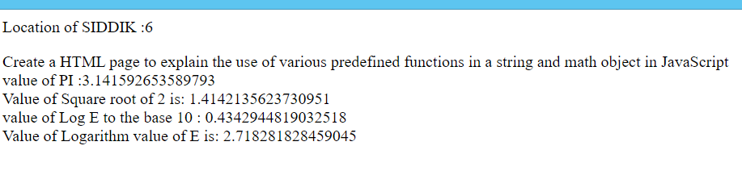

**Result**

The program was executed and the result was successfully obtained. Thus CO2 was obtained

**Experiment No.: 8                                                                         Date:28/10/2022**

**Aim:**

Create a simple calculator using javascript.

**CO2:**

Learn and design client-side validation using scripting languages.

**Procedure:**

<html>

<center>

<h1 id="h1">SIMPLE CALCULATOR</h1>

<p id="pi">

</p>

<center>

<input id="a1" type = “text”>

<input id="a2" type = “text”>

<br><br><button id="b1" > calculate sum</button><br><br>

<button id="b2" > Differnce</button><br><br>

<button id="b3" > Divition</button><br><br>

<button id="b4" > Multiplication</button><br><br>

<center>

<script>

document.getElementById("b1").addEventListener("click",fun7)

document.getElementById("b2").addEventListener("click",fun8)

document.getElementById("b3").addEventListener("click",fun1)

document.getElementById("b4").addEventListener("click",fun2)

function fun7(){

var txt1=parseInt(document.getElementById("a1").value)

var txt2=parseInt(document.getElementById("a2").value)

var sum=txt1+txt2;

document.getElementById("pi").innerHTML="Sum of "+txt1+" and "+txt2+" is "+sum;

}

function fun8(){

var txt1=parseInt(document.getElementById("a1").value)

var txt2=parseInt(document.getElementById("a2").value)

var dif=txt1-txt2;

document.getElementById("pi").innerHTML="difference of "+txt1+" and "+txt2+" is "+dif;

}

function fun1(){

var txt1=parseInt(document.getElementById("a1").value)

var txt2=parseInt(document.getElementById("a2").value)

var div=txt1/txt2;

document.getElementById("pi").innerHTML="Division of "+txt1+" and "+txt2+" is "+div;

}

function fun2(){

var txt1=parseInt(document.getElementById("a1").value)

var txt2=parseInt(document.getElementById("a2").value)

var mul=txt1*txt2;

document.getElementById("pi").innerHTML="Multiplication of "+txt1+" and "+txt2+" is "+mul;

}

</script>

</center>

**Output Screenshot:**

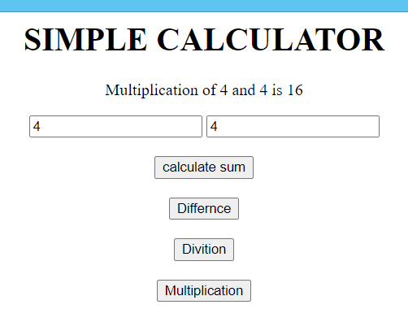

**Result**

The program was executed and the result was successfully obtained. Thus CO2 was obtained

**Experiment No.: 9 Date:28/10/2022**

**Aim:**

Evaluating JavaScript event handling for every click of a button to change the background colour of a HTML page.

**CO1:**

Explore markup languages features and create interactive web pages using them.

**Procedure:**

<html>

<center>

<h1 id="h1">Differ colors on click</h1>

<p id="pi">

</p>

<center>

<button id="b1" > Click Here </button>

<button id="b2" > change color</button>

<script>

document.getElementById("b1").addEventListener("click",fun4)

document.getElementById("b2").addEventListener("click",fun5)

function fun4(){

document.body.style.backgroundImage="url('https://images.unsplash.com/photo-1590123905258-6dfc0c298437?ixlib=rb-4.0.3&ixid=MnwxMjA3fDB8MHxzZWFyY2h8MTd8fGtvY2hpfGVufDB8fDB8fA%3D%3D&auto=format&fit=crop&w=500&q=60')";

}

function getColorCode() {

var makeColorCode = '0123456789ABCDEF';

var code = '#';

for (var count = 0; count < 6; count++) {

code =code+ makeColorCode[Math.floor(Math.random() * 16)];

}

return code;

}

function fun5(){

document.body.style.backgroundColor = getColorCode()

}

</script>

</html>

**Output Screenshot:**



**Result**

The program was executed and the result was successfully obtained. Thus CO2 was obtained.

**Experiment No.: 10 Date:17/11/2022**

**Aim:**

Generate the calendar using JavaScript code by getting the year from the user.

**CO2:**

Learn and design client-side validation using scripting languages.

**Procedure:**

<html>

<body bgcolor="skyblue">

<label> year:</label>

<input type="text" id="year">

<label> month:</label>

<input type="text" id="month">

<input type="button" id="demo" value="Generate Calender" onclick="cal()"></td>

<div id="cal">

</div>

</body>

<script>

function cal()

{

var init_cal="<table BORDER=1 id='calender'><tr><th>SUN</th><th>MON</th></th><th>TUE</th><th>WED</th><th>THU</th><th>FRI</th><th>SAT</th></tr><tr>"

var year=document.getElementById("year").value

var month=document.getElementById("month").value

month=month-1;

var date=new Date(year,month);

var day=date.getDay();

for(var i=0;i<day;i++)

{

init_cal+="<td></td>";

}

while(date.getMonth()==month)

{

init_cal+="<td>"+date.getDate()+"</td>";

if(date.getDay()==6)

{

init_cal+="</tr><tr>";

}

date.setDate(date.getDate() +1);

}

init_cal+="<table>"

document.getElementById("cal").innerHTML=init_cal;

}

</script>

</html>

**OUTPUT SCREENSHOT**

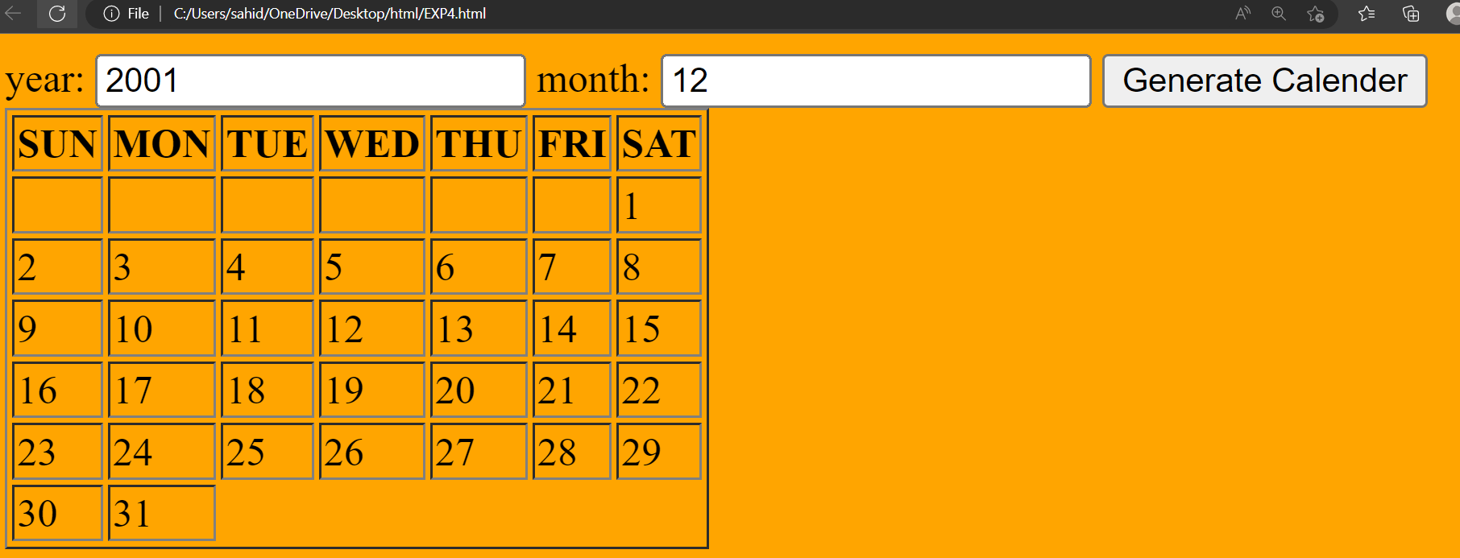

**Result**

The program was executed and the result was successfully obtained. Thus, CO2 was obtained.

**Experiment No.: 11 Date:28/10/2022**

**Aim:**

Create an HTML page to display a new image and text when the mouse comes over the existing content in the page using JavaScript event handling.

**CO2:**

Learn and design client-side validation using scripting language.

**Procedure:**

<html>

<head>

<style>

h2,p{

font-family:Garamond;

font-weight:bold;

font-size:48;

text-align:center;

color:RED;

}

</style>

<title> Colour Changer </title>

</head>

<h2>

Argentina VS Brazil

</h2>

<p id="clr">

<button id="b5" onmouseover="pic()"> SCORE CARD </button>

<script>

text="Score card--> 3:1";

//document.getElementById("pic").addEventListener("onmouseover",pic);

function pic()

{

document.body.style.backgroundImage="url('https://thumbs.dreamstime.com/b/top-view-ball-argentina-vs-brazil-flags-match-green-soccer-field-top-view-ball-argentina-vs-brazil-flags-match-215549483.jpg')";

document.getElementById("clr").innerHTML= " "+text;

}

</script>

</html>

**Output Screenshot:**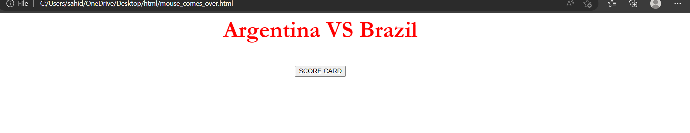

**Result**

The program was executed and the result was successfully obtained. Thus CO2 was obtained.

**Experiment No.: 12 Date:28/10/2022**

**Aim:**

Create an html page to show online exam using javascrit.

**CO2:**

Learn and design client-side validation using scripting language.

**Procedure:**

<html>

<head>

<title> ONLINE EXAM </title>

<style>

body{

background-color:teal;

display:inline-block;

}

</style>

</head>

<body>

<u> <h1 style="text-align:center";> ONLINE EXAM</h1></u>

<div style="margin=100px";>

<h3 style="font-size=25px";>

1.Gods own country is known as______________.</h3>

<input type="radio" name="q1"> Kerala<br>

<input type="radio" name="q1"> Assam<br>

<input type="radio" name="q1"> Manippal<br>

<input type="radio" name="q1"> Kashmir<br>

<h3 style="font-size=25px";>

2.TajMahal is located __________ in india. </h3>

<input type="radio" name="q2"> Kerala<br>

<input type="radio" name="q2"> Assam<br>

<input type="radio" name="q2"> Delhi<br>

<input type="radio" name="q2"> Kashmir<br>

q3

<h3 style="font-size=25px";>

3.Harihar fort is in ___________.</h3>

<input type="radio" name="q3">Maharasta<br>

<input type="radio" name="q3"> Kerala<br>

<input type="radio" name="q3"> Delhi<br>

<input type="radio" name="q3" Punjab<br>

<input type="SUBMIT" value="submit" onclick="result()">

</div>

<script>

function result(){

var score=0

if(document.getElementById("q1").checked)

{

score++

}

if(document.getElementById("q2").checked)

{

score++

}

if(document.getElementById("c").checked)

{

score++

}

document.write("Your Score is:",score);

}

</script>

</body>

</html>

**Output Screenshot:**

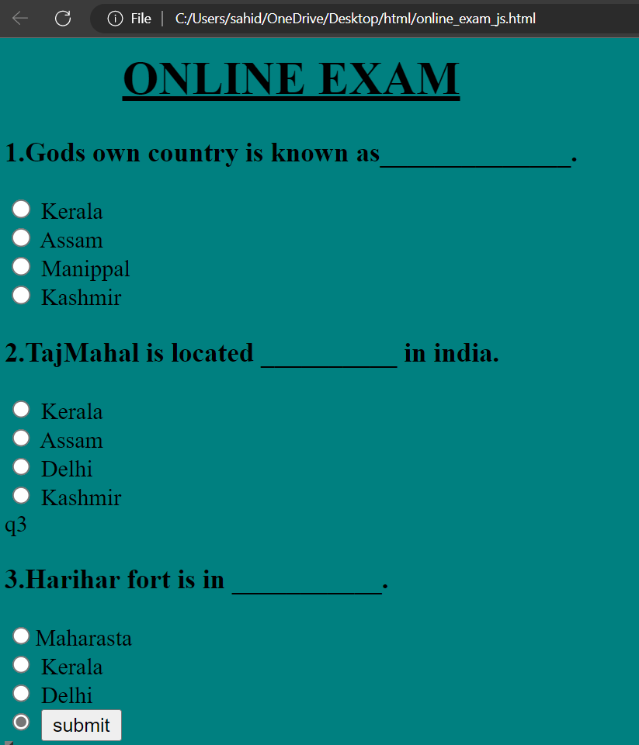

**Result**

The program was executed and the result was successfully obtained. Thus CO2 was obtained.

**Experiment No.: 13 Date:28/10/2022**

**Aim:**

Compose electricity bill from user input based on a given tariff using PHP.

**CO4:**

Do client-side & server side scripting.

**Procedure:**

<?php

$amount=NULL;

if (isset($_POST["calc"])){

$total_units=$_POST["watts"];

if ($total_units < 51)

$amount += (3.50*$total_units);

else if($total_units > 50 && $total_units < 151){

$amount += (3.50*50);

$amount += (4.00*($total_units-50));

}

else{

$amount += (3.50*50);

$amount += (4.00*100);

$amount += (5.20*($total_units-150));

}

}

?>

<html>

<head>

<title>Electricity Bill Calculator</title>

</head>

<style>

table{

}

</style>

<body>

<form action="#" method="post">

<table>

<tr>

<td><input type="text" name="watts" id="wt" placeholder="Total Units Consumed"></td><td><input type="submit" name="calc" value="Click Here"></td>

</tr>

<tr>

<td colspan="2" align="center">Amount:<?php echo $amount ?></td>

</tr>

</table>

</form>

</body>

</html>

**Output Screenshot:**

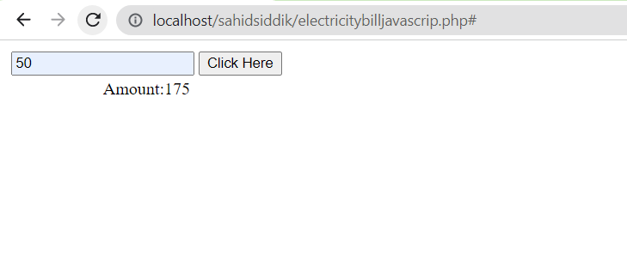

**Result**

The program was executed and the result was successfully obtained. Thus CO4 was obtained.

**Experiment No.: 14 Date:28/11/2022**

**Aim:**

Build a PHP code to store name of students in an array and display it using print_r

function. Sort and Display the same using asort & arsort functions.

**CO4:**

Do client-side & server side scripting.

**Procedure:**

<?php

$students = array("Ammu", "Jessy", "Sneha", "Naveen", "Amjith", "Abhilash", "Raju");

echo "Normal Array : <br>"

print_r($students);

echo "<br><br> Ascending Sort : <br>";

asort($students);

print_r($students);

echo "<br><br> Descending Sort : <br>";

arsort($students);

print_r($students);

echo($students[1])

?>

**Output Screenshot:**

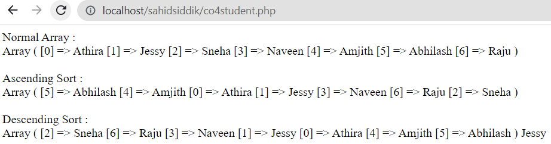

**Result**

The program was executed and the result was successfully obtained. Thus CO4 was obtained.

**Experiment No.: 15 Date:28/10/2022**

**Aim:**

Build a php code to store name of Indian cricket players in array and display the same in html table.

**CO4:**

Do client-side & server side scripting.

**Procedure:**

<?php

$name=array("Kapil Dev","Rahul Dravid","Sachin Tendulkar","Sunil Gavaskar","MS Dhoni","Dilip Vengasarkar","Shikhar Dhawan"," BS Chandrashekhar");

$age=array("1","2","3","1","2","3","4","8");

  echo ("Array is:<br>");

  print_r($name);

  echo "<table border=1>";

       echo "<tr>";

          echo "<th> NAME OF PLAYERS</th>";

       echo "</tr>";

       for($i=0; $i<count($name);$i++){

           echo "<tr>";

            echo "<td>$name[$i] </td>";

           echo "</tr>";

        echo "<tr>";

           echo "<td> Age = $age[$i]</td>";

        echo "</tr>";

       }

?>

**Output Screenshot:**

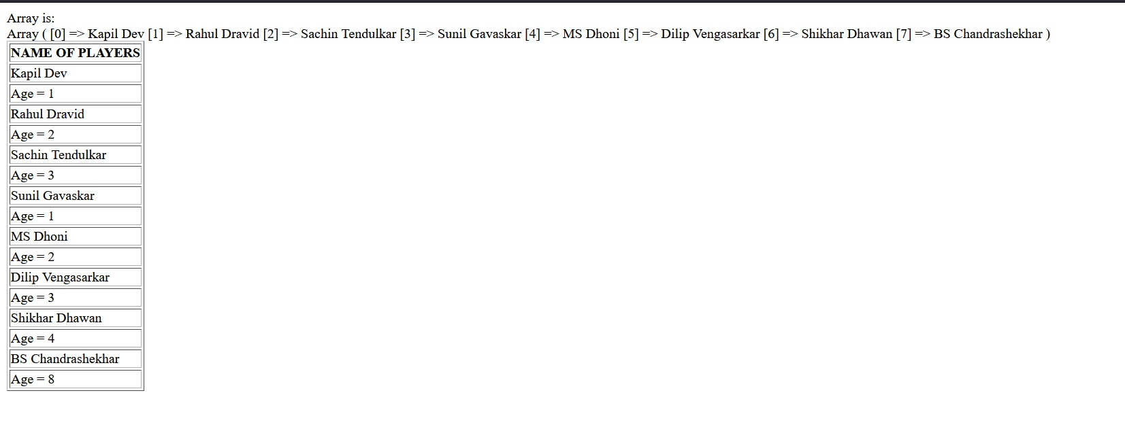

**Result**

The program was executed and the result was successfully obtained. Thus CO4 was obtained.